**FinancialEdge Acct #:** __________________________________

**Date Received:** ________________________

**Credit Card (16 digit) #:** ________________________________

**Teller Initials/#:** _______________/________

**Cardholder Name:** ____________________________________

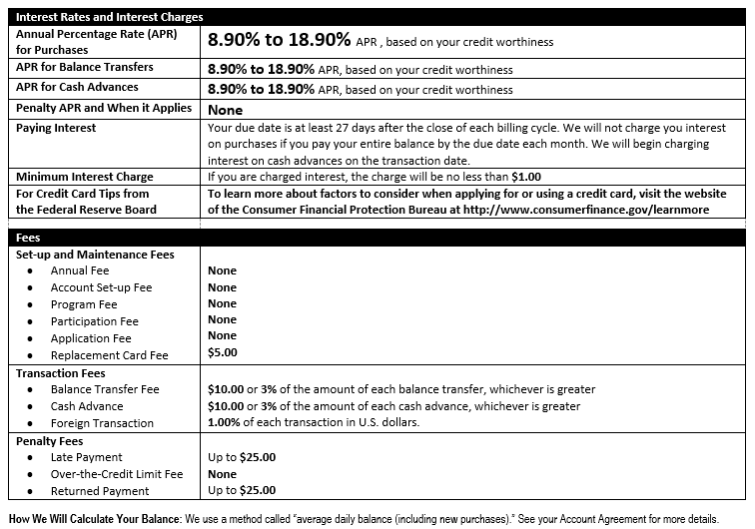

|  |  |  |
| --- | --- | --- |
| **MERCHANT/BANK** | **ACCOUNT NUMBER** | **REQUEST TO TRANSFER $$** |
|  |  | $ . |
|  |  | $ . |
|  |  | $ . |
|  |  | $ . |
|  |  | $ . |
|  |  | $ . |

**Special $0 Balance Transfer Fee\***

*\* Balance transfer not offered on existing FinancialEdge Credit Card balances.*

Member Signature: ____________ Date: